HOTELS IN THE WINCHCOMBE AREA
http://www.hotels.uk.com/search/area_lon_lat_view_locations.php?town=Winchcombe&region=E6&order=dist&page=11
http://www.winchcombe.co.uk/about-winchcombe/things-to-do/local-accommodation
http://www.cotswolds.info/accommodation/winchcombe-lodgings.shtml

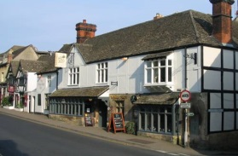 | The White Hart Inn  High Street, Winchcombe, Cheltenham, Winchcombe, Gloucestershire, GL54 5LJ  We are 0.24 miles from Winchcombe Centre  More Info. | Rooms From  £ 79.00
Rising Sun Hotel  Cleeve Hill, Winchcombe, Gloucestershire, GL52 3PX  We are 2.70 miles from Winchcombe Centre  More Info. |  | Rooms From  £ 40.00
Dumbleton Hall Hotel  Near Evesham, Buckland, Gloucestershire, WR11 7TS  We are 4.82 miles from Winchcombe Centre  More Info. |  | Rooms From  £ 67.00
Cotswold Grange  Pittville Circus Rd, Cheltenham, Gloucestershire, GL52 2QH  We are 5.19 miles from Winchcombe Centre  More Info. |  | Rooms From  £ 58.90
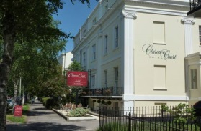 | Clarence Court Hotel  Clarence Sq, Cheltenham, Gloucestershire, GL50 4JR  We are 5.45 miles from Winchcombe Centre  More Info. | Rooms From  £ 55.00
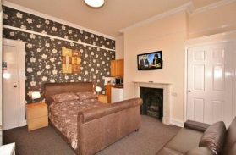 | Central Hotel  7 Portland Street, Cheltenham, Gloucestershire, GL52 2NZ  We are 5.62 miles from Winchcombe Centre  More Info. | Rooms From  £ 34.00
The Charlton Kings Hotel  London Road, Cheltenham, Gloucestershire, GL52 6UU  We are 5.62 miles from Winchcombe Centre  Tel: 01242 2... Click for Number | Hotel Website | More Info. |  | Rooms From  £ 59.00

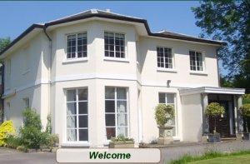 | Detmore House  London Road, Cheltenham, Gloucestershire, GL52 6UT  We are 5.63 miles from Winchcombe Centre  Tel: 01242 5... Click for Number | Hotel Website | More Info. | Rooms From  £ 65.00

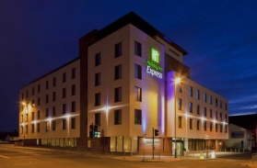 | Holiday Inn Express Cheltenham Town Centre  Dunalley Street, Cheltenham, Gloucestershire, GL50 4AP  We are 5.64 miles from Winchcombe Centre  More Info. | Rooms From  £ 49.00
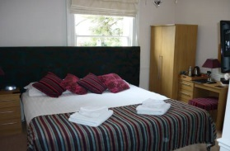 | Hilden Lodge  271 London Road, Cheltenham, Gloucestershire, GL52 6YG  We are 5.68 miles from Winchcombe Centre  More Info. | Rooms From  £ 48.00
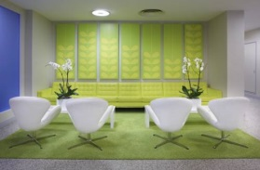 | The Big Sleep Hotel Cheltenham by Compass Hospitality  Wellington Street, Cheltenham, Gloucestershire, GL50 1XZ  We are 5.78 miles from Winchcombe Centre  More Info. | Rooms From  £ 58.50
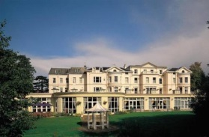 | Cheltenham Park Hotel  Cirencester Rd, Cheltenham, Gloucestershire, GL53 8EA  We are 6.38 miles from Winchcombe Centre  More Info. | Rooms From  £ 59.00
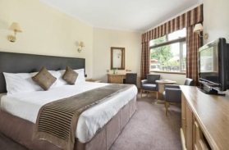 | Jurys Inn Cheltenham  Gloucester Road, Cheltenham, Gloucestershire, GL51 0TS  We are 7.96 miles from Winchcombe Centre  More Info. | Rooms From  £ 60.00
Bell Hotel  Church St, Tewkesbury, Gloucestershire, GL20 5SA  We are 8.77 miles from Winchcombe Centre  More Info. |  | Rooms From  £ 30.00

B&Bs & GUEST HOUSES IN THE WINCHCOMBE AREA
http://www.bedandbreakfasts.co.uk/gloucestershire/winchcombe/

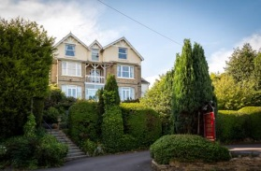 | Cleeve Hill House  Cleeve Hill, Winchcombe, Gloucestershire, GL52 3PR  We are 2.58 miles from Winchcombe Centre  More Info. | Rooms From  £ 65.00
Homelands Bed And Breakfast  Butts Lane, Woodmancote, Winchcombe, Gloucestershire, GL52 9QH  We are 3.28 miles from Winchcombe Centre  More Info. |  | Rooms From  £ 98.72

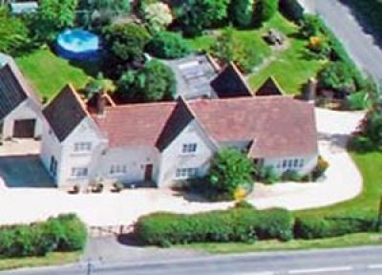 | Corner Cottage Bed and Breakfast  Corner Cottage Stow Road, Tewkesbury, Gloucestershire, GL20 8NH  We are 3.42 miles from Winchcombe Centre  Tel: 01242 6... Click for Number | Hotel Website | More Info. | Rooms From  £ 70.00
Thrift Cottage  , Winchcombe, Gloucestershire, GL52  We are 3.73 miles from Winchcombe Centre  More Info. |  | Rooms From  £ 98.72

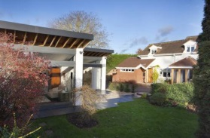 | The Walnut Store  Walnut Cottage, Cheltenham, Gloucestershire, GL52 3DH  We are 4.32 miles from Winchcombe Centre  More Info. | Rooms From  £ 85.00

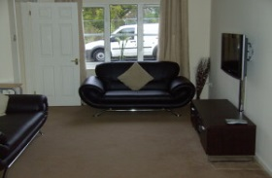 | The Corner House  Canters Drive, Cheltenham, Gloucestershire, GL52 8YF  We are 4.34 miles from Winchcombe Centre  More Info. | Rooms From  £ 119.00
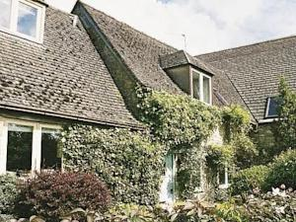 | Yoke Cottage  , Buckland, Gloucestershire, GL54  We are 4.41 miles from Winchcombe Centre  More Info. | Rooms From  £ 98.72

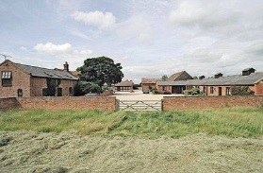 | Lime Cottage  , Buckland, Gloucestershire, WR11  We are 4.66 miles from Winchcombe Centre  More Info. | Rooms From  £ 98.72

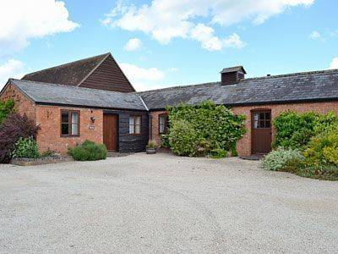 | Elm End  , Buckland, Gloucestershire, WR11  We are 4.66 miles from Winchcombe Centre  More Info. | Rooms From  £ 98.72

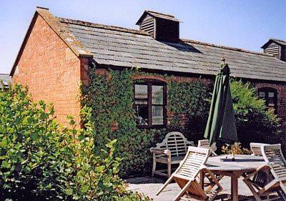 | The Willows  , Buckland, Gloucestershire, WR11  We are 4.66 miles from Winchcombe Centre  More Info. | Rooms From  £ 98.72

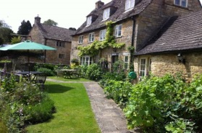 | Guiting Guest House  Post Office Lane, Guiting Power, Gloucestershire, Naunton, Gloucestershire, GL54 5TZ  We are 4.80 miles from Winchcombe Centre  More Info. | Rooms From  £ 80.00
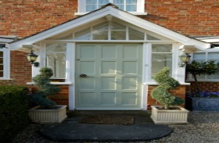 | Glenfall Farm Bed and Breakfast  Glenfall Farm Bed and Breakfast, Ham Road, Charlton Kings, Cheltenham, Cheltenham, Gloucestershire, GL52 6NH  We are 4.94 miles from Winchcombe Centre  More Info. | Rooms From  £ 95.00

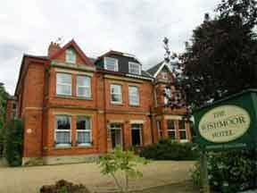 | Wishmoor House  147 Hales Road, Cheltenham, Gloucestershire, GL52 6TD  We are 5.08 miles from Winchcombe Centre  More Info. | Rooms From  £ 54.00
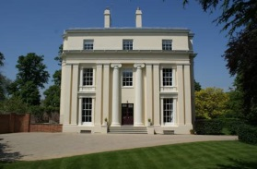 | Ravenhurst Bed and Breakfast  93 Pittville Lawn, Cheltenham, Gloucestershire, GL52 2BP  We are 5.15 miles from Winchcombe Centre  More Info. | Rooms From  £ 187.50

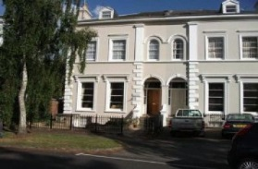 | Parkview Guest House  4 Pittville Crescent, Cheltenham, Gloucestershire, GL52 2QZ  We are 5.16 miles from Winchcombe Centre  Tel: 01242 5... Click for Number | Hotel Website | More Info. | Rooms From  £ 25.00

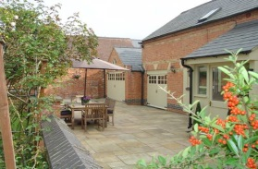 |  | Holiday home The Coach House  The Coach House, Kingswood House, Pittville Circus Road, Cheltenham, Gloucestershire, GL52 2PZ, Cheltenham, Gloucestershire, GL52 2PZ  We are 5.18 miles from Winchcombe Centre  More Info. |  |  |  |  | Rooms From  £ 98.72
 | The Annexe The Chase, Greenway Lane, Cheltenham, Cheltenham, Gloucestershire, GL52 6PN We are 5.21 miles from Winchcombe Centre More Info. Rooms From £ 75.00 |  |  |  |  |  |  |  | Top of Form  Bottom of Form
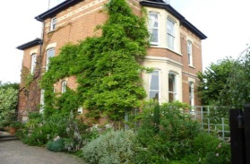 |  | Laurel House Bed and Breakfast  143 Hewlett Road, Cheltenham, Gloucestershire, GL52 6TS  We are 5.30 miles from Winchcombe Centre  More Info. | Rooms From  £ 57.50
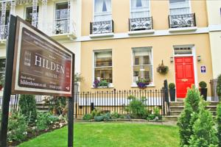 |  | Hilden House  20 Evesham Road, Cheltenham, Gloucestershire, GL52 2AB  We are 5.42 miles from Winchcombe Centre  More Info. | Rooms From  £ 55.00
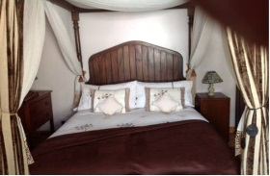 |  | Alice Guest house  141 Swindon road, Cheltenham, Gloucestershire, GL51 9EW  We are 5.79 miles from Winchcombe Centre  More Info. |  | Rooms From  £ 40.00

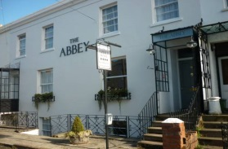 | The Abbey  14-16 Bath Parade, Cheltenham, Gloucestershire, GL53 7HN  We are 5.85 miles from Winchcombe Centre  More Info. | Rooms From  £ 46.20
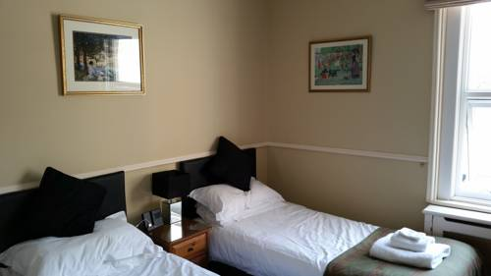 | Crossways Guest House  57 Bath Road, Cheltenham, Gloucestershire, GL53 7LH  We are 5.92 miles from Winchcombe Centre  More Info. | Rooms From  £ 45.00
Bentons Guest House  71 Bath Road , Cheltenham, Gloucestershire, GL53 7LH  We are 5.95 miles from Winchcombe Centre  More Info. |  | Rooms From  £ 35.00

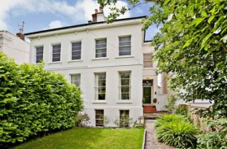 | 104) 15 Old Bath Road  Old Bath Road, Cheltenham, Gloucestershire, GL53 7QE  We are 6.35 miles from Winchcombe Centre | Rooms From  £ 50.00
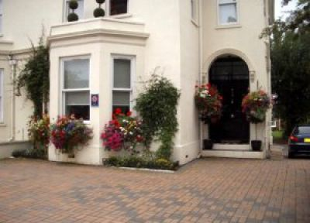 | 116) Burlington House  418 Gloucester Road, Cheltenham, Gloucestershire, GL51 7TB  We are 7.17 miles from Winchcombe Centre  Tel: 01242 5... Click for Number | Hotel Website | More Info. | Rooms From  £ 52.00
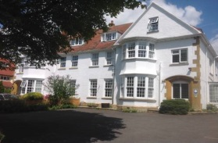 | 120) Apple Tree House Bed and Breakfast  Station Road, Broadway, Hereford and Worcester, WR12 7DE  We are 7.40 miles from Winchcombe Centre  More Info. | Rooms From  £ 55.00
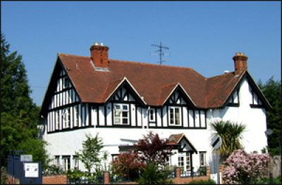 | White Lodge  Hatherley Lane, Cheltenham, Gloucestershire, GL51 6SH  We are 7.99 miles from Winchcombe Centre  Tel: 01242 2... Click for Number | Hotel Website | More Info. | Rooms From  £ 50.00

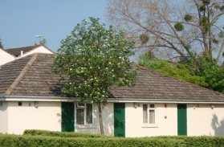 | Briarfields Motel  Gloucester Road, Cheltenham, Gloucestershire, GL51 0SS  We are 8.08 miles from Winchcombe Centre  More Info. | Rooms From  £ 39.99

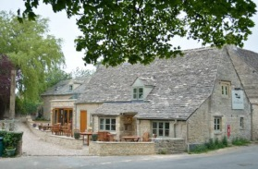 | The Plough Inn, Cold Aston  The Plough Inn, Cold Aston, Cheltenham, GLOS, Naunton, Gloucestershire, GL54 3BN  We are 8.26 miles from Winchcombe Centre  More Info. | Rooms From  £ 80.00
The Green Dragon Inn  Cockleford, Birdlip, Gloucestershire, GL53 9NW  We are 9.20 miles from Winchcombe Centre  More Info. |  | Rooms From  £ 57.00

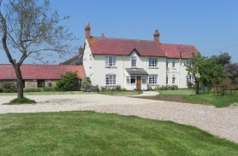 | Lowerfield Farm  Willersey Fields, Broadway, Hereford and Worcester, WR11 7HF  We are 9.25 miles from Winchcombe Centre  Tel: 01386 8... Click for Number | Hotel Website | More Info. | Rooms From  £ 65.00

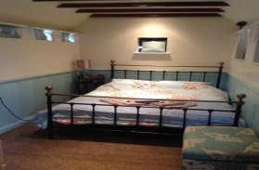 | Lower lode inn  Forthampton, Tewkesbury, Gloucestershire, GL19 4RE  We are 9.30 miles from Winchcombe Centre  More Info. | Rooms From  £ 50.00
Frogmill Inn  The Frogmill, Cheltenham, Gloucestershire, GL54 4HT  We are 6.00 miles from Winchcombe Centre  More Info. |  | Rooms From  £ 49.00

APARTMENTS, SELF CATERING & CARAVAN PARKS IN THE WINCHCOMBE AREA
http://www.winchcombe.co.uk/about-winchcombe/things-to-do/local-accommodation
http://www.cotswolds.info/accommodation/winchcombe-lodgings.shtml
http://www.campingandcaravanningclub.co.uk/campsites/uk/gloucestershire/nrtewkesbury/winchcombe

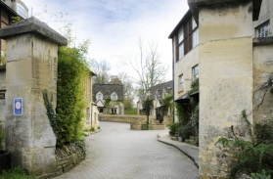 | Sudeley Castle Cottages  Castle Street, Winchcombe, Winchcombe, Gloucestershire, GL54 5JA  We are 0.25 miles from Winchcombe Centre  More Info. | Rooms From  £ 98.72
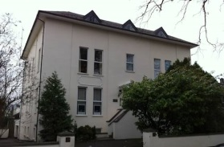 | John Forbes House  John Forbes House, Apartment 9, 15 Pittville Crescent, Cheltenham, Gloucestershire, GL52 2QZ  We are 5.13 miles from Winchcombe Centre  More Info. | Rooms From  £ 98.72
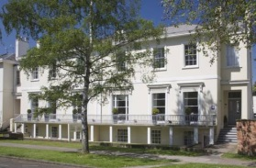 | The Cheltenham Townhouse and Apartments  12-14 Pittville Lawn, Cheltenham, Gloucestershire, GL52 2BD  We are 5.38 miles from Winchcombe Centre  More Info. | Rooms From  £ 65.00

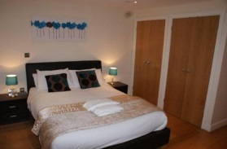 | Grosvenor House Apartments - Cheltenham  13-19 Evesham Road, Cheltenham, Gloucestershire, GL52 2AA  We are 5.40 miles from Winchcombe Centre  More Info. | Rooms From  £ 149.00
Evesham Road Serviced Properties  Evesham Road, Cheltenham, Gloucestershire, GL52 2AA  We are 5.43 miles from Winchcombe Centre  More Info. |  | Rooms From  £ 55.00
Trinity Lane - Central Cheltenham  Trinity Lane, Cheltenham, Gloucestershire, GL52 2NT  We are 5.54 miles from Winchcombe Centre  More Info. |  | Rooms From  £ 39.00

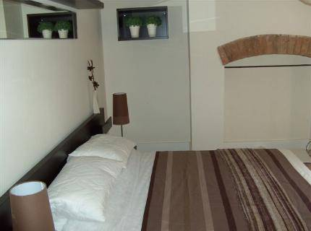 | Bliss Luxury Living  71 B Hewlett Road, Cheltenham, Gloucestershire, GL52 6AF  We are 5.55 miles from Winchcombe Centre  More Info. | Rooms From  £ 76.50
Warwick Place Apartments  Warwick Place, Cheltenham, Gloucestershire, GL52 2NP  We are 5.56 miles from Winchcombe Centre  More Info. |  | Rooms From  £ 69.00

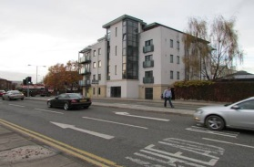 | Cheltenham Luxury Apartments  Warwick Place Off Portland Street, Cheltenham, Gloucestershire, GL52 2NB  We are 5.57 miles from Winchcombe Centre  More Info. | Rooms From  £ 83.00
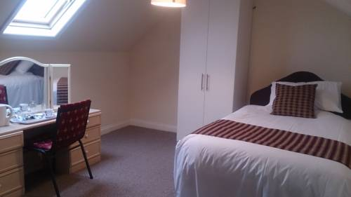 | Paul's Road Rooms  51 St Pauls Road,, Cheltenham, Gloucestershire, GL50 4EZ  We are 5.58 miles from Winchcombe Centre  More Info. | Rooms From  £ 49.00

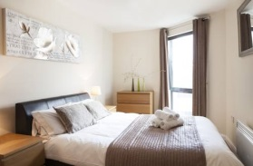 | Cheltenham Plaza Apartments  Portland Street, Cheltenham, Gloucestershire, GL52 2NB  We are 5.58 miles from Winchcombe Centre  More Info. | Rooms From  £ 94.00

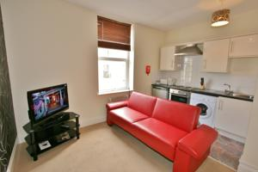 | Portland Street Apartments  7-9 Portland Street, Cheltenham, Gloucestershire, GL52 2PB  We are 5.59 miles from Winchcombe Centre  More Info. | Rooms From  £ 132.00

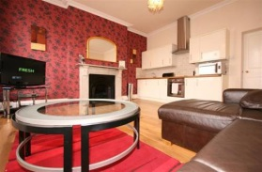 | Albion Street Hotel Serviced Apartments  Albion Street, Cheltenham, Gloucestershire, GL52 2RW  We are 5.59 miles from Winchcombe Centre  More Info. | Rooms From  £ 39.00

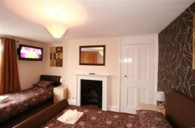 | Central Studio Rooms - Portland Street  18 Portland Street, Cheltenham, Gloucestershire, GL52 2PB  We are 5.60 miles from Winchcombe Centre  More Info. | Rooms From  £ 29.00

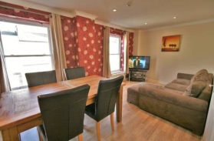 | Central Serviced Apartments  7-9 Portland Street, Cheltenham, Gloucestershire, GL52 2NZ  We are 5.61 miles from Winchcombe Centre  More Info. | Rooms From  £ 49.00

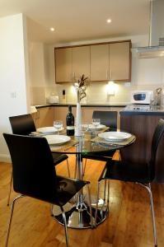 | The Palisades  Hewlett Road, Cheltenham, Gloucestershire, GL52 6AD  We are 5.62 miles from Winchcombe Centre  More Info. | Rooms From  £ 119.00

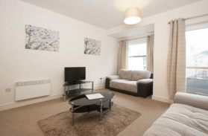 | The Coliseum Apartments  18-20 Albion Street, Cheltenham, Gloucestershire, GL52 2LP  We are 5.62 miles from Winchcombe Centre  More Info. | Rooms From  £ 89.00

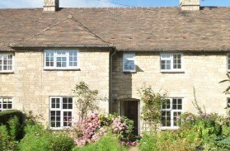 | Swallows Rest  , Buckland, Gloucestershire, WR12  We are 5.62 miles from Winchcombe Centre  More Info. | Rooms From  £ 98.72
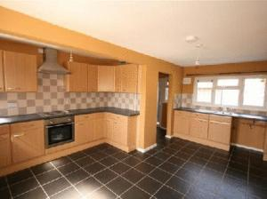 | 56) Castle Studios - Portland Street  7 - 9 Portland Street, Cheltenham, Gloucestershire, GL52 2NZ  We are 5.62 miles from Winchcombe Centre  More Info. | Rooms From  £ 22.00
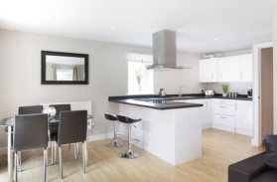 | Saracens Courtyard Apartments  St Georges Street, Cheltenham, Gloucestershire, GL50 4DE  We are 5.70 miles from Winchcombe Centre  More Info. | Rooms From  £ 79.00

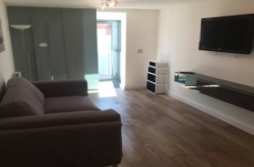 | Number 18  18 St Pauls Street South, Cheltenham, Gloucestershire, GL50 4AW  We are 5.72 miles from Winchcombe Centre  More Info. | Rooms From  £ 95.00

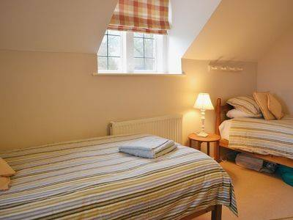 | Glebe Cottages  , Buckland, Gloucestershire, WR12  We are 5.77 miles from Winchcombe Centre  More Info. | Rooms From  £ 98.72
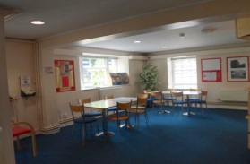 | Cheltenham YMCA  6 Vittoria Walk, Cheltenham, Gloucestershire, GL50 1TL  We are 5.96 miles from Winchcombe Centre  More Info. | Rooms From  £ 25.00
Central Serviced Apartments - 84 Gloucester Rd  84 Gloucester Rd, Cheltenham, Gloucestershire, GL51 8NZ  We are 6.19 miles from Winchcombe Centre  More Info. |  | Rooms From  £ 39.00
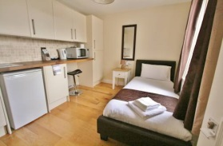 | Central Studios Gloucester Road  298 Gloucester Road, Cheltenham, Gloucestershire, GL51 7AG  We are 6.87 miles from Winchcombe Centre  More Info. | Rooms From  £ 25.00

Swallows at Roel Hill Farm
Hawling, Cheltenham, Gloucestershire, GL54 5AP
Tel: 01451 850955 Mobile: 07909 773094
Email:paul.hazel@roel-hill-farm.co.uk www.roel-hill-farm.co.uk
Luxury self contained Studio flat.

Cottage to rent in Filkins
Delightful cottage available in Filkins
Cotswold Woollen Weavers is happy to say that Inns Cottage is now available for short term let... Anything over three nights.
Inns Cottage is completely refurbished, and ideal for friends on holiday, family overflows, wedding and other party guests... Indeed anyone looking for an idyllic Cotswold cottage.
(And of course you can pop directly across the village road to sample the delights of Cotswold Woollen Weavers and its coffee-shop.)
42 minutes/25 miles from Sudeley
45 minutes/27 miles from Cheltenham
wool.weavers@dial.pipex.com
Filkins, GL73JJ

Winchcombe Camping and Caravanning Club Site, Brooklands Farm, Alderton, Nr Tewkesbury,Gloucestershire, GL20 8NX
Open: 09 Mar 2015 - 12 Jan 2016
Open: 04 Mar 2016 - 09 Jan 2017
Open: 03 Mar 2017 - 08 Jan 2018
Pitches: 80
Phone number: 01242 620259
Managers: Ian Thomas & Susan Liggett
Latitude: 51.99052 Longitude: -1.99047
Self-catering accommodation is available at this campsite

